|  |  |  |  |
| --- | --- | --- | --- |
| API Creation   |  | | --- | | Here is the details about API, the description of API | | Page for which I go through is shown in image | | Table1 is showing Base_url, API_endpoints, Description, and Paylosds | |

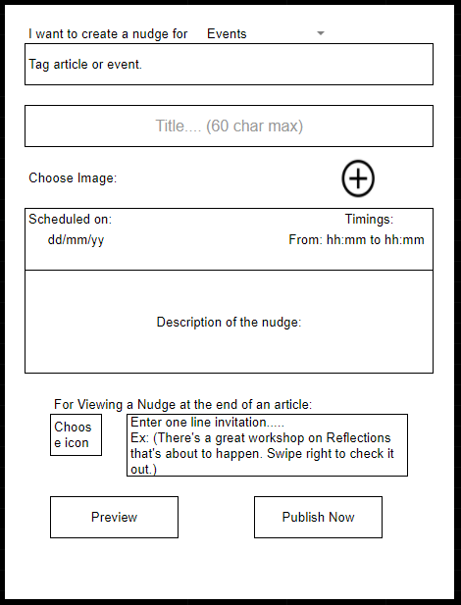

|  |  |  |  |  |  |
| --- | --- | --- | --- | --- | --- |
| Widget | Request Type | Base URL | API Endpoint | Payload | Description |
| Nudge | POST | /api/v3/app | /nudges | event (required), title (required), cover_image (optional), time (required), description (required), icon (optional), invitation (optional): | Creates an Nudge and returns the Id of the event i.e. created |
| GET | /api/v3/app | /nudges/:id |  | Retrieve an Nudge by its unique id |
| PUT | /api/v3/app | /nudges/:id | Same as POST payload | Updates an Nudge and returns the Id of the event |
| DELETE | /api/v3/app | /nudges/:id |  | Deletes an Nudge based on its Unique Id |
| POST | /api/v3/app | /nudges/:id/cover_image | cover_image | Upload a cover image for a specific nudge by ID |

Object Data Model-

|  |  |
| --- | --- |
| **Object Data Model of an Nudge** | **type:**"event" **uid:**123 (user id), **Title**: The title of the nudge **schedule**: (Date + time) The time at which the nudge will be sent **files[cover image]**: The cover image for the nudge. (File upload) **invitation**:The one-line invitation for the nudge.  **icon**: The icon for the nudge  **description**: String (The description of the nudge) |

CRUD Functionalities

The Nudge API supports the following CRUD (Create, Read, Update, Delete) functionalities:

|  |  |
| --- | --- |
| CRUD Function | Description |
| Create | To create a new nudge, send a POST request to the /nudges endpoint with the nudge data in the request body. The response will include the created nudge object. |
| Read | To retrieve a specific nudge by ID, send a GET request to the /nudges/:id endpoint with the ID of the nudge in the URL. The response will include the retrieved nudge object |
| Update | To update a specific nudge by ID, send a PUT request to the /nudges/:id endpoint with the ID of the nudge in the URL and the updated nudge data in the request body. The response will include the updated nudge object. |
| Delete | To delete a specific nudge by ID, send a DELETE request to the /nudges/:id endpoint with the ID of the nudge in the URL. The response will include a success message. |